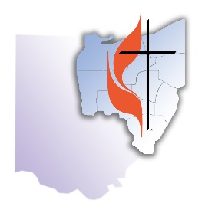

East Ohio Conference of The United Methodist Church
8800 Cleveland Ave. NW • PO Box 2800 • North Canton, OH 44720
Phone: (330) 499-3972 • Website: www.eocumc.com

June 27, 2015

The United States Supreme Court ruling, that state prohibitions against same-gender marriage are unconstitutional, is consistent with our United Methodist position that everyone should have equal treatment under the law.

I celebrate the fact that we live in a country that seeks to treat everyone equally and does not restrict religious freedom. However, the ruling by the U.S. Supreme Court does not determine our theological position.

The United Methodist Church is a worldwide denomination that has yet to recognize same-gender marriages, allow its pastors to perform same-gender weddings, or allow its churches to be used for such services.

The traditional Christian view is that marriage, by definition, is between a man and a woman.

While some members of our church have advocated for a change in both the law and our theological position, others have advocated for a change in civil law while maintaining our theological position on marriage. Still, others have advocated for no change in the law or our theology.

Our theological position on marriage will undoubtedly be debated during General Conference 2016 in Portland, OR. What is decided there – by delegates from around the world – will apply to all United Methodist churches in our country and abroad.

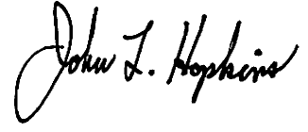
Bishop John L. Hopkins
East Ohio Conference
The United Methodist Church

